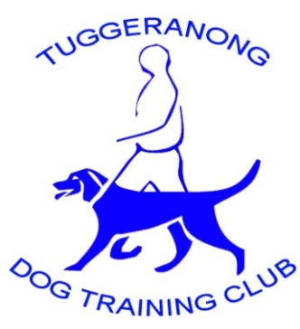 |  | Tuggeranong Dog Training Club  Rowland Rees Crescent,  PO Box 1803  GREENWAY ACT 2902  ABN 88 459 488 440

Notice of the Annual General Meeting
The Annual General Meeting of the Tuggeranong Dog Training Club (TDTC) will be held on Wednesday 30th October 2024 at the Tuggeranong Dog Training Club at 1900 hours.
As required under our Constitution, the Annual General Meeting shall:
- confirm the minutes of the preceding Annual General Meeting and of any general meeting held since that meeting;
- receive and consider the annual report of the Committee;
- receive and consider a balance sheet and statement of accounts for the preceding financial year;
- elect the incoming Committee for the ensuing year; and
- decide on any resolution which may be duly submitted to the meeting.
All current Full Members are invited and encouraged to attend, and if interested to nominate for the Committee. Nomination forms are available from the Club House and must be submitted to the Secretary prior to the commencement of the AGM.
If any member wishes to bring any business before the AGM please give written notice of that business to the Secretary no later than 14 days prior to the meeting.

Signed
The Secretary

